**Unit-IV: Link building and content consideration**

**Precursors to link building, elements of link building, finding your competition, analyzing your**

**competition, competitor tracking, becoming a resource, content duplication, content verticals,**

**sitemaps.**

**4.1 What is Link Building & Why is It Important?**

Whether you’re brand new to link building or have been doing it for a while, we’re sure you’ll find something useful in this guide. The landscape of SEO and link building is always changing, and today, the importance of building high-quality links has never been higher.

The need to understand and implement high-quality campaigns is essential if you’re going to compete and thrive online, and that isn’t going to change any time soon. This guide is designed to get you going quickly and in the right direction. There is a lot to take in, but we’ve broken everything up into easy-to-digest chapters and have included lots of examples along the way. We hope you enjoy The Beginner’s Guide to Link Building!

**Definition of Link Building**

Link building is the process of acquiring hyperlinks from other websites to your own. A hyperlink (usually just called a link) is a way for users to navigate between pages on the internet. Search engines use links to crawl the web; they will crawl the links between the individual pages on your website, and they will crawl the links between entire websites.

There are many techniques for building links, and while they vary in difficulty, SEOs tend to agree that link building is one of the hardest parts of their jobs. Many SEOs spend the majority of their time trying to do it well. For that reason, if you can master the art of building high-quality links, it can truly put you ahead of both other SEOs and your competition.

**Why is Link Building Important for SEO?**

In order to understand the importance of link building, it’s important to first understand the basics of how a link is created, how the search engines see links, and what they can interpret from them.

1. **Start of link tag:**

Called an anchor tag (hence the “a”), this opens the link tag and tells search engines that a link to something else is about to follow.

**2. Link referral location:**

The “href” stands for “hyperlink referral,” and the text inside the quotation marks indicates the URL to which the link is pointing. This doesn’t always have to be a web page; it could be the address of an image or a file to download.

**3. Visible/anchor text of link:**

This is the little bit of text that users see on the page,and on which they need to click if they want to open the link. The text is usually formatted in some way to make it stand out from the text that surrounds it, often with blue color and/or underlining, signaling to users that it is a clickable link.

**4. Closure of link tag:**

This signals the end of the link tag to the search engines.

**What Links Mean for Search Engines**

There are two fundamental ways that the search engines use links:

**1) To discover new web pages**

**2) To help determine how well a page should rank in their results**

Once search engines have crawled pages on the web, they can extract the content of those pages and add it to their indexes. In this way, they can decide if they feel a page is of sufficient quality to be ranked well for relevant keywords (Google created a short video to explain that process). When they are deciding this, the search engines do not just look at the content of the page; they also look at the number of links pointing to that page from external websites and the quality of those external websites. Generally speaking, the more high-quality websites that link to you, the more likely you are to rank well in search results.

However, SEOs soon discovered how to manipulate Page Rank and search results for chosen keywords. Google started actively trying to find ways to discover websites which were manipulating search results, and began rolling out regular updates which were specifically aimed at filtering out websites that didn’t deserve to rank.

Weighting of Thematic Clusters of Ranking Factors in Google

It is generally accepted that if all other factors are equal, the volume and quality oflinks pointing to a page will make the difference between rankings. Having said that, with recent moves from Google, including the release of Penguin updates andits push of Google+, there is speculation that the impact of links is being reduced and replaced with social signals such as tweets or +1s.

* Domain-Level, Keyword-Agnostic Features (e.g. domain name length, extension, domain HTTP response time, etc.)
* Page-Level Link Features (e.g. PageRank, TrustRank, quantity of link links, anchor text distribution, quality of links sources, etc.)
* Page-Level KW & Content Features (e.g. TF*IDF, topic-modeling scores on content, content quantity/relevance, etc.)
* Page-Level, Keyword-Agnostic Features (e.g. Content length, readability, uniqueness, load speed, etc.)
* Domain-Level Brand Features (e.g. ofhine usage of brand/domain name, mentions of brand.domain in news/ media/press, entry association, etc.)
* User, Usage, & Traffic/ Query Data (e.g. traffic/ usage signals from browsers/ toolbars/clickstrean, quantity/ diversity/ CTR of queries, etc.)
* Social Metrics (e.g. quantity/quality of tweeted links Facebook shares, Google +1s, etc.)
* Domain-Level Keyword Usage (e.g. exact-match keyword domains, partial-keyword matches, etc.)
* Domain-Level, Keyword-Agnostic Features (e.g. domain name length, TLD extension, domain HTTP response time, etc.)

It is generally accepted that if all other factors are equal, the volume and quality of links pointing to a page will make the difference between rankings. Having said that, with recent moves from Google, including the release of Penguin updates and its push of Google+, there is speculation that the impact of links is being reduced and replaced with social signals such as tweets or +1s.

**How Can Link Building Benefit My Business?**

As we’ve discussed, links are a very important signal that the search engines use to determine rankings. So, we know that increasing the number of high-quality links pointing at your website can significantly increase your chances of ranking well. There are other benefits to link building, though, that may be less immediately obvious yet still worthy of consideration.

1. Building Relationships

2. Sending Referral Traffic

3. Brand Building

**Building Relationships**

Link building can often involve outreach to other relevant websites and blogs in your industry. This outreach frequently relates to the promotion of something that you’ve just created, such as a piece of content or an infographic. A common goal of outreach is to get a link, but there is much more to it than just this: Outreach can help you build long-term relationships with key influencers in your industry, and these relationships can mean that your business becomes highly regarded and trusted.

**Sending Referral Traffic**

We’ve talked about the impact of links on your rankings, but what about the impact of links on referral traffic? A good link from a highly-visited website can lead to an increase in traffic, too. If it is a relevant website, chances are that the traffic is also relevant and may lead to an increase in sales, as well.

**Brand Building**

Good link building can help build your brand and establish you as an authority in your niche. There are some link building techniques, such as content creation, which can show people the expertise of your company, and this can go a long way toward building your brand. For **example,** if you create a piece of content based upon industry data and publish it, you have a chance of becoming well known for it in your industry.

**What Types of Links You Need**

When defining the strategy for your link building campaign, you will need to think about the types of links you need to get. There are various types to consider:

1. Links to your homepage

2. Links to “deep” pages (such as product or category pages)

3. Links containing your brand / company name

4. Links containing the keywords you’re targeting

**4.2 Elements of link building**

**Within SEO, link building plays an important role in driving organic traffic via search engines, especially in competitive industries. When combined with strong technical SEO foundations, great on-page SEO, excellent content, and a good user experience, link building can be super effective at driving more organic traffic.**

Today, the need for quality, relevance, and authenticity has never been more important. While low-quality, spammy link building techniques can work, they shouldn’t play a part in a strategy for an organization who is building for long-term organic search success.

[Link building](https://moz.com/beginners-guide-to-link-building) is how you create and acquire hyperlinks (or simply links) to your website. There are essentially two types of links that make up a link building strategy.

## Internal Links

* An [internal link](https://yoast.com/internal-linking-for-seo-why-and-how/) is any hyperlink that takes people from one page of your website to another.
* Your website’s navigation bar is a perfect example of internal links. For instance, if someone clicks on How It Works in my site’s navigation bar, it takes them to the page on my website that details how my business’ services work.
* Internal links can also be found within blog posts and articles. Below is a section of an article I’ve recently published here where I’ve included an internal link.

## External Links

Also called [backlinks](https://www.searchmetrics.com/glossary/backlinks/), these connect content published from another website to a page or article posted on your site.

 One example of this is this link in an author bio of a [guest post I contributed to Influence&Co](https://blog.influenceandco.com/7-local-facebook-marketing-strategies-to-engage-your-audience).

##### Why Should You Build Links for Your Website

## Organize Your Website’s Content

* How your website’s content’s organized can significantly impact your user experience and your website’s search rankings in the long run.
* Search engine bots are scouring the Internet to find and index new content as you’re reading this. They do this by [following links on previously published content](https://developers.google.com/search/docs/beginner/how-search-works) like a web page or blog post.

## Improve User Experience

* Through link building, you can map out your website’s content, making it easier for your visitors to find the information they’re looking for. The same thing goes for Google and other search engine bots.
* Also, Google recently announced that it’d be rolling out its [Page Experience algorithm update](https://www.searchenginejournal.com/google-page-experience-algorithm-update-launching-in-mid-june/403023/) by the middle of June 2021. Among the factors that will now play an integral role in how Google will rank websites will be your visitors’ overall user experience.

## Boost Search Rankings

* Backlinks are one of the [critical factors Google considers](https://www.monsterinsights.com/google-ranking-factors/) when ranking websites on their SERPs. Websites that rank #1 in Google’s search results has nearly 4x more backlinks than other websites listed on Google’s SERPs.

## Build Your Online Reputation

* When you link relevant articles you’ve published to each other, you’re allowing your visitors to keep on consuming your content while learning more about the topic they’re interested in.
* Eventually, Google will take notice and equate this to the quality of the content you’re publishing. As a result, Google will reward you with higher search rankings, especially when those websites linking back to your website are considered reputable authorities within your industry.

##### Scalability

* To grow your business, you’ll need to be able to automate your workflows, delegate tasks, and even outsource specific processes.
* Unfortunately, you can’t do any of these with link building, especially when building backlinks to your website.
* The reason: Google puts more emphasis on the quality of the backlinks your content’s getting over the quantity. Neil Patel and his team discovered this when they tested the effects [one backlink from a high domain authority website](https://neilpatel.com/blog/links-building-google/) will have on a website’s search rankings.

### Changes in Google’s Algorithm

* Many of the [recent Google Algorithm updates](https://www.seroundtable.com/category/google-updates) have significantly changed many of the SEO best practices you’ve grown accustomed to using, including your link building strategy.
* A perfect example of this was when [Google released two new link attributes in 2019](https://developers.google.com/search/blog/2019/09/evolving-nofollow-new-ways-to-identify) for external links included in guest posts and sponsored posts.
* Although these new link attributes aren’t as harsh as the “no follow” link attribute, it does give Google the final say on whether or not it’ll consider your backlink in a specific guest post when they rank your website.

## Proving Your Link Building Strategy ROI

* Although link building does provide your business with a host of benefits, it can still be tough to get your boss to buy into this. That’s because it can be challenging to calculate and track its ROI.
* There’s no particular metric that clearly shows the direct effects link building has on your business’ bottom line, for starters.
* Second, other factors can affect your ability to drive qualified traffic to your website so you can convert them into leads.
* Finally, building backlinks is an [off-page SEO](https://www.webceo.com/blog/what-is-off-page-seo-and-how-manage-it/) technique. As such, you have no way of knowing how they’ll perform.

## How To Build Quality Links With Content Marketing

One of the most popular marketing strategies used today, [content marketing](https://contentmarketinginstitute.com/what-is-content-marketing/) focuses on consistently publishing high-quality content that’s helpful to your target audience. Its goal is to provide your target audience with the information they’re looking for so that they’d eventually decide to become your customer.

 For this very reason, content marketing is one of the most effective ways to build quality internal and external links for your website.The key here is to ensure that the content you publish is appealing to your target audience and Google.

 Here are some suggestions:

##### 1. List Posts

Of the different content types published, this is still the most widely used. And for good reason.

List posts make your content easy for your site visitors to scan and skim your content. This is crucial since [studies have consistently shown](https://www.nngroup.com/articles/how-people-read-online/?lm=how-users-read-on-the-web&pt=article) that people scan—not read—online content, as these heatmaps show.

##### 2. Infographics

* Infographics are another type of content to include in both your content marketing and link building strategies.
* If you don’t know [what infographics are](https://infogram.com/page/infographic), they’re a type of content that presents facts, figures, and other information visually.
* When creating an infographic to publish, the challenge is that you need to find that “perfect” balance between text and graphics. Even though many [infographic-making platforms](https://www.creativebloq.com/infographic/tools-2131971) come with templates to help you get started, you’ll need to have a good eye for design to complete it.

**3. Original Research and Data**

* Just like with creating infographics, publishing original research you’ve conducted is exceptionally tedious. After all, not all businesses have the resources to allocate to do this.
* However, the rewards you’ll get in building quality backlinks for your website will make this all worthwhile. On top of that, publishing original research as an industry report helps position you and your brand as reputable experts in your industry.

##### 4. In-Depth Guides

* An in-depth guide is a comprehensive resource that covers everything that your target audience wants to know.
* There are three reasons why an in-depth guide is great content to use for your link building strategy.
* Work like original research reports. Since in-depth guides are incredibly comprehensive, many sites would often use these as references for their articles and blog posts, helping you build quality backlinks.
* They are evergreen. You don’t need to write a brand-new guide each year on the same topic. Instead, you can just update this so that it stays current.

**4.3 Finding your competition**

**a)Who are your competitors?**

1. All businesses face competition. Even if you're the only restaurant in town you must compete with cinemas, bars and other businesses where your customers will spend their money instead of with you.

2. With increased use of the Internet to buy goods and services and to find places to go, you are no longer just competing with your immediate neighbours. Indeed, you could find yourself competing with businesses from other countries.

3. Your competitor could be a new business offering a substitute or similar product that makes your own redundant.

4. Competition is not just another business that might take money away from you. It can be another product or service that's being developed and which you ought to be selling or looking to license before somebody else takes it up.

1. And don't just research what's already out there. You also need to be constantly on the lookout for possible new competition.

**You can get clues to the existence of competitors from:**

i. local business directories

ii. your local Chamber of Commerce

iii. advertising

iv. press reports

v. exhibitions and trade fairs

vi. questionnaires

vii. searching on the Internet for similar products orservices

viii.information provided by customers

ix. flyers and marketing literature that have been sent to you - quite common if you're on a bought- in marketing list

x. searching for existing patented products that are similar to yours

xi. planning applications and building work in progress

**b)What you need to know about your competitors**

1) the products or services they provide and how theymarket them to customers

2) the prices they charge

3) how they distribute and deliver

4) the devices they employ to enhance customerloyalty and what back-up service they offer

5) their brand and design values

6) whether they innovate - business methods as well as products

**c)Learning about your competitors**

1)Read about your competitors. Look for articles or ads in the trade press or mainstream publications. Read their marketing literature.

2)Check their entries in directories and phone books. If they are an online business, ask for a trial of their service.

3)Are they getting more publicity than you, perhaps through networking or sponsoring events?

4)If your competitor is a public company, read a copy of their annual report.

5)At exhibitions and trade fairs check which of your competitors are also exhibiting. Look at their stands and promotional activities. Note how busy they are and who visits them.

6)Look at competitors' websites. Find out how they compare to yours. Check any interactive parts of the site to see if you could improve on it for your own website. Is the information free of charge? Is it easy to find?

7)Business websites often give much information that businesses haven't traditionally revealed - from the history of the company to biographies of the staff.

8)Use a search engine to track down similar products. Find out who else offers them and how they go about it.

9)Websites can give you good tips on what businesses around the globe are doing in your industry sector.

**d) Hearing about your Competitors**

1. Speak to your competitors. Phone them to ask for acopy of their brochure or get one of your staff or a friend to drop by and pick up their marketing literature.

2. You could ask for a price list or enquire what an off- the-shelf item might cost and if there's a discount for volume. This will give you an idea at which point a competitor will discount and at what volume.

3. Phone and face-to-face contacts will also give you an idea of the style of the company, the quality of their literature and the initial impressions they make on customers.

4. Listen to your customers and suppliers

5. Use meetings with your suppliers to ask what their other customers are doing. They may not tell you everything you want to know, but it's a useful start.

## How to Do a Competitive Analysis

Learn the best way to conduct a competitor analysis, and how it can help you improve your products or services.

• Conduct a routine competitor analysis to understand your competitors' strengths and weaknesses, and to identify gaps in the marketplace.

• A competitor analysis can help you enhance your product or service, better serve your target audience, and increase your profits.

• A competitor analysis should include your competitors' features, market share, pricing, marketing, differentiators, strengths, weaknesses, geography, culture

and customer reviews.

• This article is for new and established small business owners who want to analyze their competition to improve their products or services.

**Why is a competitor analysis important?**

1) It is important to conduct routine competitor analyses throughout the lifecycle of your business to stay up to date with market trends and product offerings. A competitor analysis can reveal pertinent information about market saturation, business opportunities and industry best practices.

2) It is also important to know how your customers view you in comparison to your competition. A competitor analysis will give you a better idea of what services are currently available to your target customer and what areas are being neglected.

**Key takeaway: A competitor analysis teaches you important information about your market that empowers you to make well-informed business decisions.**

**What are the benefits of conducting a competitor analysis?**

1) Analyzing your business against your competitors can help you in many ways. For example, it will reveal which areas of your business, product or service need improvement.

1. With this knowledge, you can adjust your processes to better serve your target market and increase profit. It can also show you new strategic opportunities to enhance your products or services and grow your business.
2. Once you conduct a competitor analysis, you can use it for bench marking and measuring future growth. Routine analyses will reveal market trends to keep track of and new players to be aware of.
3. It will also help reveal who your current competitors are through out every stage of business. Be sure to keep your analyses up to date.

**4.4 Analyzing your competition**

A business establishment must always have a competitive analysis of itscompetitors and how their products and service compare. With such an evaluation, the company can have a gauge on how its product and service can either have an edge or a deficiency against its competitors. Consequently, modifying its products attributes will attract its target market.

**There are three types of competitors to be evaluated:**

• Direct

• Indirect

• Potential New Entrants

**Two Ways to Improve your Competitive Position**

**1. Call for Research Partners**

We are currently building our 2017 research calendar and are looking forcompanies focused on finding out why customers say “yes” in the areas of subscription, lead gen, nonprofit and ecommerce. To learn more, visit: MECLABS.com/Partners

**2. Online Certification Courses**

Get the certified in MECLABS Institute’s patented methodology for website optimization and value proposition development. To learn more, visit: MECLABS.com/Courses

**Task 1: Competitor Profile**

Complete your competitor profile and a profile for your three most important competitors – use the recommended sources to find the data and try and get as much info as possible.

**Task 2: Competitive Advantage**

Think about what makes your company different than your competitors. Next, do the same thing for your three competitors. If you’re struggling, pick up the phone and give your competitors a call – just ask them! Go one step further and actually talk to their customers.

**Task 3: Target Market**

Identify who your target market is (if you don’t already know) and then do some research on your competitors to see who their target market is. A good place to start would be their website and looking at their advertising campaigns.

**Task 4: Market Share**

Complete a market share analysis.

**Task 5: Marketing Strategies**

Write down your current marketing strategies and any you have in the pipeline. Now get moving and see what your competitors are doing – give them a call, do some research on their site – do whatever you can to become more familiar with their strategies.

**Task 6: Product/Service Profile**

Complete the product/service mix– rate your company then your competitors on a consistent scale of 1-10.

**Task 7: Pricing and Costs**

Answer all these questions about your company and your competitors. Pricing is an observable source so you should be able to get most of the answers by looking at your competitors offerings.

**Task 8: Distribution Channels**

Look at your company’s and your competitor’s distribution channels – how many channels and intermediaries are being used? Do they spend more time in front of the clients?

**Task 9: SWOT Analysis**

Complete a SWOT analysis for your company and your competitors.

**Key Elements of a Competitive Analysis Template**

Let’s start with the key elements. When making this analysis, you will have to include

these essential components to make it complete and effective. As long as all the

elements are applicable to your company, you need to add them in. Here they are**:**

**A Complete List of All Your Competitors**

First and foremost is acquiring a list of your competitors. Know your enemies. Gather all available and relevant information about these companies. Rank them by

considering who the chief competitors are. Some can indirectly compete with yours,

but since they offer the same products and services aiming at the same customer

capital, include them in the list as well.

**Product Summary of Your Competitors**

Do research on all information regarding the competition’s products and services, their features, their value, their goals. Find out their sales strategies. A customer survey conducted by the trade press is valuable aids in finding out customer satisfaction about competitors.

**Strengths and Weaknesses of the Competition**

Be objective in assessing the strength and weakness of your competitor’s product. Assume the position of being the competition.

**Here are the different types of competitors:**

**Direct**

Businesses that sell the same type of goods and services that you do to the same

market. Examples of this are: gift shops, convenient stores, flower shops

**Indirect**

Businesses that sell substitute products and services or items that can be used in

place of yours. If you own a bakery, an indirect competitor will be a restaurant.

Or owning a picture frame shop, an indirect competitor will be a craft store.

**Potential New Entrants**

The company should be aware of the entry of new business

establishments offering the same products and service. This will result in further

analysis of your current and future competition.

**Tips on Writing a Great Competitive Analysis Template**

**Learn by Being the Customer**

Visit competing establishments as a customer. Communicate with these companiesthrough telephone or better yet, the internet. Observe how they respond to your queries. It will reveal a lot about your competition, some good (which you can later adapt for your business) and some bad (which should be avoided).

**Look Into Your Competition**

The best way to measure the capabilities of your competition is by appropriatingsome time to investigate your competitor’s personnel. Could you do this face-to- face? if yes, better. Otherwise, the internet, newspapers, people outside that company will also be an effective substitute.

**Purchase Stocks from your Competitors**

This is s good tip. In buying even a few stocks in your competitor’s company entitles to receive regular updates on the firm’s financial results and business strategies, as well as information about the firm’s future plans.

**Make Use of the Internet**

The internet these days is the best source in retrieving information. Some online services can provide you literature about your competitors, especially if they are large companies.

**4.5 Competitor tracking**

Competitive marketing strategies are strongest either when they position a firm's strengths against competitors' weaknesses or choose positions that pose no threat to competitors. As such, they require that the strategist be as knowledgeable about competitors' strengths and weaknesses as about customers' needs or the firm's own capabilities. This chapter is designed to assist the strategist understand how to gather and analyze information about competitors that is useful in the strategy development process. It discusses the objectives of competitor analysis and proceeds through the processes involved in identifying important competitors and information needs, gathering necessary information, and interpreting this information.

**THE OBJECTIVES OF COMPETITOR ANALYSIS**

The ultimate objective of competitor analysis is to know enough about a competitor to be able to think like that competitor so the firm's competitive strategy can be formulated to take into account the competitors' likely actions and responses. From a practical viewpoint, a strategist needs to be able to live in the competitors’ strategic shoes.

The strategist needs to be able to understand the situation as the competitors see it and to analyze it so as to know what actions the competitors would take to maximize their outcomes to be able to calculate the actual financial and personal outcomes of the competitor’s strategic choices.

They must be able to:

1. Estimate the nature and likely success of the potential strategy changes available to a competitor; 2. Predict each competitor’s probably responses to important strategic moves on the part of the other competitors; and

3. Understand competitors’ potential reactions to changes in key industry and environmental parameters. What then should one expect from competitor analysis?

Underneath all of the complexities and depth of competitor analysis are some simple and basic practical questions, of which the following are typical:

• Which competitors does our strategy pit us against?

• Which competitor is most vulnerable and how should we move on its customers?

**IDENTIFYING COMPETITORS**

Identifying competitors for analysis is not quite as obvious as it might seem. Two complementary approaches are possible. The first is demand-side based, comprised of firms satisfying the same set of customer needs.

The second approach is supply-side based, identifying firms whose resource base, technology, operations, and the like, is similar to that of the focal firm. However, the firm must pay attention not only to today's immediate competitors but also to those that are just over the horizon (such as cellphones once were to cameras, social networking sites once were to web portals, or the internet once was to video rental stores).

There are three domains for recognizing the sources and types of direct and less direct competitors to which the firm must also attend. These domains represent (1) the areas of influence, (2) the contiguous area, and (3) the areas of interest.

**Identifying Competitors at the Product-Market Level**

The most direct competitor competes for the exact same customers in exactly the same way as the subject firm. It sells the same product made by the same technology to the same customers via the same marketing channels. If the firm cannot win customer patronage versus such an identical competitor, then it is unlikely that it can do any better competing against its indirect or potential competitors. Why? If the firm's exact counterpart can win in direct competition, then that same competitor should also win more against the less direct competitors.

Companies, per se, do not compete with each other in the marketplace. Rather, their individual businesses compete with each other. The strategic marketing literature denotes a business as a division, product line, or other profit center with a company that produces and markets a well-defined set of related products and/or services, serves a clearly defined set of customers, and competes with a distinct set of competitors.3

A business is further defined in terms of a number of key dimensions, which reflect the ways and places in which it has chosen to compete. Primary among these are the products it offers and the types of customers to whom it chooses to sell.

**The products a firm offers can be defined along three dimensions: functions, technology, and materials:**

• Customer function is concerned with what need is being satisfied. This is the most natural way to think about a product. Electromechanical devices, for example, can frequently be designed to satisfy any size set of functions from very narrow to very wide. For example, some cooking appliances are single function (microwave ovens), others are dual function (combination convection-microwave ovens), while others are multifunction

Technology tells how the customer function(s) are being satisfied. For example, kitchen ranges may use two sources of thermal energy (gas or electric) or, alternatively, microwave energy to cook. X rays, computerized axial tomography (CAT scan machines), and NMR (nuclear magnetic resonance) are three different technologies used in medical diagnostic imaging

The materials used in the manufacture of the product may also differ, producing slight differences in products that are otherwise identical. Cabinets may be made of chipboard versus plywood; bottles of glass or of such plastics as PET, polypropylene, or polyethylene; and beverage cans of aluminum or steel.

The customer group being served is a key dimension. Automobile parts manufacturers, for example, may choose to serve either the original equipment manufacture (OEM) market or the automotive aftermarket, or both. One competitor may focus on serving urban markets while another serves rural markets.

**Identifying Potential Competitors**

Depending on the purposes of the competitive analysis, it may also be important to identify potential competitors. The process starts by identifying firms for whom the various barriers to entry to the industry are low or easily surmountable. These may include the following:

• Technology: Firms which possess the technologies necessary to operate in an industry represent one source of potential competitors. Analysis of patent activity frequently signals intentions well prior to actual entrance.

• Market access: In businesses where market access is a key factor for success, firms with that access frequently attempt to leverage it by acquiring additional product lines to be sold in that channel or to those customers.

• Reputation and image: Brand extension strategies are based on the use of a firm's reputation in one product area to leverage its entry into another. Clairol used its reputation in hair coloring to enter into the hair dryer business.

* Operating knowledge and skills: Regional competitors in a business often expand geographically. Entenmann's Bakeries moved into Florida and Midwestern markets from their original Northeastern base, similar to the path taken by Thomas's English Muffins. Folger's coffee was originally a regional brand on the West Coast until purchased by Procter & Gamble which expanded its distribution nationwide.

**Identifying Competitors at the Firm Level**

The concept of interfirm rivalry extends beyond the product/market level. Competition can also occur as firms use related resources to bear on individual product/market level rivalry. The theory of multimarket competition describes those situations in which firms compete against each other in multiple markets.

The strategic group approach to identifying competitors is based on the differences in firms' strategies for competing in an industry. As such, it is a more general concept than the business definition approach. Like the business definition approach, the concept is intuitively appealing and understandable. For example, a hypothetical industry may be composed of three strategic groups:

1. A set of large firms pursuing a strategy of low-cost production of a full line of standardized products through mass-market outlets;

2. Another set of firms whose strategy emphasizes high-quality, differentiated, and branded products sold through specialty shops;

**Competitive Blind Spots**

Much competitive information is bounded by the assumptions that managers’ have with respect to their industry and these assumptions may lead to blind spots. The effect of such blind spots may cause the strategist to not recognize the significance of events, interpret them inappropriately, or see them only slowly.

1.Misjudging Industry Boundaries. Too often firms define their industry around their current products, customer groups, and geographies blinding themselves to adjacent competitors which subsequently enter their current space.

2. Poor Identification of Competitors. Strategists frequently focus on only the largest and most well-known companies to the exclusion of other viable competitors – those potential competitors noted earlier in this chapter.

3. Overemphasis on Competitors’ Visible Competence. Competitor analysis often focuses on competitors’ hard assets and technology skills and ignore equally potent capabilities such as logistics, product design, or human resources.

4. Emphasis on Where, Not How to Compete. Strategists too often assume that competitors’ strategies will shift only incrementally to the exclusion of radical repositioning in how they could compete.

1. Faulty Assumptions about Competitors. Prisoners of assumptions about competitors – the overuse of stereotypes – cause strategists to misjudge competitors’ competences and competitive advantages.

**4.6Becoming a resource**

Having the right set of software tools to manage data insights, content and digital marketing is essential! Without the right ones, you won't be able to create a strategy which reaches target customers and follower them through the customer journey - giving you insights into customer journeys, personas, conversion rate optimization and many more digital metrics essential to staying ahead of competitors.

The digital tools we recommend will be categorized into our [essential toolkits:](https://www.smartinsights.com/digital-marketing-advice/)

1. Search Engine Optimization: Organic search
2. Paid Search: AdWords
3. Analytics
4. Social Media Marketing (PR and influencer)
5. Email Marketing / Marketing Automation
6. Content Marketing

The aim is to provide you with a list of the multitude of different tools available and a comparison of features for various industries, products or services. If used correctly, they can help streamline your digital marketing effectiveness.

### **Search Engine Optimization: Organic search**

There are many free and paid premium tools available to help improve and guide your SEO tasks. It's vital to consider both on-page and off-page SEO techniques to optimize your copy for search rankings. There are 6 types of SEO tools:

* Audience insights (which is covered later)
* Analytical tools (which is covered later)
* Keyword analysis
* Rank checking
* Site crawling
* Backlink analysis

#### **Keyword analysis and customer search analysis**

1. Google Keyword Planner - Google offers a range of different tools and analytical platforms to keep data analysists happy - they are never without tools which help you plan, manage and optimize SEM strategies. Keyword Planner can be located within your AdWords dashboard under 'tools'. You can still use it even if you don't invest in AdWords. This is a great tool which allows you see the average monthly search volume for keywords and your average organic position for it. It also allows you to filter keywords by location and set parameters for Google or Google and search partners.
2. [Google Trends](https://trends.google.com/trends/) - A good tool for understanding seasonal content. It also displays results in a more visual way but presents much simpler results than Keyword Planner. It shows interest in keywords and search queries, but doesn't give you the exact number of searches or your organic position. It is definitely worth having with Keyword Planner, but I wouldn't recommend only using Trends.
3. [SEMrush](https://www.semrush.com/) - a free or paid tool which has features such as seeing keywords your competitors are ranking, the value of keywords, and the landing page for each keyword. This tool gives you a great insight into keyword research, a vital stage in planning your SEO strategy.

#### **Rank checking**

1. Google Search Console - this does more than rank checking! This gives you a view of your site via the 'backdoor'. Check your search appearance and how your amp pages are performing, as well as links to your site and crawl errors.
2. [Moz Pro Rank Tracker](https://moz.com/tools/rank-tracker) -  Moz Pro tracks selected rankings data over time to see which efforts are making the most impact as well as schedule automated reports to stay informed on changes. This is compatible with the major search engines, Google, Yahoo! and Bing.
3. [Advanced Web Tracking](https://www.advancedwebranking.com/) (AWR) - This allows you to view your rankings daily, weekly or on demand. You can access reports from any device. However, it also offers a plethora of other useful services like localization, Developer API, and even social media exposure.

#### **Site crawling**

1. Google Search Console
2. [Screamingfrog](https://www.screamingfrog.co.uk/seo-spider/) - Not only does screamingfrog crawl for broken links (404s) it also offers an SEO crawling feature called SEO spider. This crawls website links, images, CSS, and script from an SEO perspective and reports on how SEO friendly your pages are.
3. [Yoast](https://yoast.com/) - a very useful and FREE (or freemium) WordPress plugin which analyses page copy in a traffic light signal basis for how SEO friendly the copy is based on keyword density, alt-attributes, SEO titles and Meta descriptions, slug etc. It cannot guarantee ranking, as it in no way affects search engine algorithms, but gives a great estimate of how well your copy is written based on your keyword. This is great to use as a guided SEO editor whilst you write and makes you aware of key on-page SEO techniques you should be utilizing.

#### **Backlink analysis**

1. [Buzzsumo](http://buzzsumo.com/) - Not available on its free version, the backlink tracker allows you to identify who links to your competitors and analyze their most shared backlinks. With Buzzumo you can also see your social share for each URL, your most shared content on social and find influencers.
2. [Majestic Backlink History Checker](https://majestic.com/reports/compare-domain-backlink-history) - This is a great premium tool. This allows marketers to see the number of backlinks their site has for their domains, subdomains, and even individual URLs. They track, over time, the number of backlinks so you can see in a visual graph the volume of backlinks you receive. you can also compare competing domains.

### **Analytics**

Having the right set of analytics tools is vital - a good analysis tool will give you all the data you need to know about campaigns that you're running, projects and other key metrics for your company's all-round performance. They can also give your valuable insight into your customers' behaviour patterns.

1. Google Analytics - you'll find that unless companies use paid analytical tools such as Adobe, then you'll certainly have a Google Analytics account. There is a premium version, but for $150,000 per year.
2. Kissmetrics - This allows segmented conversion  tracking, reporting on individual registered users and simple retargeting options through promotional banners.

#### **Social Media Publishing**

1. Buffer - We use Buffer at Smart Insights as it allows us to schedule in posts across LinkedIn, Twitter, Facebook, Pinterest, Google+ and Instagram. It has a feature for most popular content that allows you to 'rebuffer' and share again.
2. [IFTTT](https://ifttt.com/) - This automation tool allows you to connect your social media accounts together. For example, posting a picture on your Instagram will mean IFTTT automatically posts the native image to your Twitter, or Facebook depending on how you've set it up. It's great for keeping all your content aligned on various channels.

### **Content marketing management**

1. [WordPress](https://wordpress.com/) - a free and open-source content management system based on PHP and MySQL. This is a great content management system to build your site.
2. [Smartling](https://www.smartling.com/) - Smartling’s Translation Management Platform is an end-to-end solution for digital content translation designed to simplify and streamline translation by eliminating 90% of the manual processes and costs associated with localization. Smartling’s advanced technology centralizes global content in the cloud and integrates seamlessly with any tech stack to provide visibility through a centralized workplace and deploy flexible workflows that enable team efficiency and ensure translation accuracy.
3. [Trello](https://trello.com/) - Trello is easy and simple to use and makes organizing content much more efficient. We have lists for different campaign content, which we assign to internal team members to remind them of content that needs writing. It's a great way to organize and distribute content to team members and keep track of ideas.

### **Marketing automation tools**

Email service providers and marketing automation services include:

1. [GetResponse](https://www.getresponse.co.uk/) - GetResponse offers email marketing, webinars, landing page creation and marketing automation. Their email marketing services allows businesses to set up auto-responders, advanced analytics, a/b testing, and forms. You can also plan and build individual customer journeys through their marketing automation, with automation segmentation, basket abandonment, and web event tracking.
2. [DataBowl](https://www.databowl.com/) -  Operating as a standalone data management platform, or easily integrating with your existing system, DataBowl generates, runs and automates B2C marketing campaigns from conception through to completion. Ensuring international, on-demand monitoring of accuracy, quality and performance, alongside the eradication of fraudulent data.

### **UX and page insights tools**

Making sure your pages/site is accessible and provide a fast and clear user experience is essential in keeping your audience on your site and browsing. [Google has announced](https://www.smartinsights.com/search-engine-optimisation-seo/mobile-seo/alert-googles-mobile-speed-update/) that they will now take Page Speed into account when indexing mobile pages so having a fully optimized page that loads fast is vital, not just for UX but for search ranking.

1. [PageSpeed Insights](https://developers.google.com/speed/pagespeed/insights/) - this is a simple tool provided by Google which shows the page speed of your site / URLs (and your competitors) - if it is slow they also offer insights into how to improve your page speed.
   1. **Content duplication**

Duplicate content is content that appears on more than one online location, meaning different websites. If you publish your own content in more than one place, you have [duplicate content](https://neilpatel.com/blog/how-to-deal-with-duplicate-content-issues-including-those-created-by-your-cms/). If you copy someone else’s content onto your site or if they publish yours on their site, that’s duplicate content.

Search engines can have a difficult time determining which content is more relevant to a query in the search engine when content is too similar. The goal of search engines is to give users the best results possible when they search for a particular term. Google and other search engines may choose to exclude duplicate content from their search engine queries.

## **Some Causes of Duplicate Content**

In many cases, the use of duplicate content is not intentional or intended to be malicious. [Google refers to duplicate content](https://searchengineland.com/myth-duplicate-content-penalty-259657) as blocks of text that are identical or “appreciably similar” within or across domains. Examples of non-malicious duplicate content include store item descriptions and printer-only versions of web pages.

Deliberate duplication of content is another matter. When the same content is used on multiple domains in an attempt to increase traffic or manipulate search engine rankings, it can be frustrating for people who are attempting to search for information and end up getting the same content in multiple places. This is why search engines do their best to discourage this practice.

## **Using Google to check for Duplicate Content**

One quick way to check if a page may be considered duplicate is by copying around ten words from the start of a sentence and then pasting it with quotes into Google. This is actually Google’s recommended way to check.

If you test this for a page on your website, you would expect to see only your webpage to show up and ideally with no other results.

If other websites show as well as your site, Google hints that it thinks the original source is the result it shows first. If this isn’t your website, you may have a duplicate content issue.

## **Free Tools to Check for Duplicate Content**

When you are writing your content, you may unintentionally make your content too similar to already-published content. It’s always a good idea to double check everything you write using plagiarism checkers to make sure your content is viewed as unique.

[Copyscape](https://www.copyscape.com/) – This tool can quickly check the content that you have written against already published content in a matter of seconds. The comparison tool will highlight content that shows up as duplicate, and it will let you know what percentage of your content matches already-published content.

[Plagspotter](http://www.plagspotter.com/) – This tool can identify duplicate pages of content across the web. It’s a great tool for finding plagiarists who have stolen your content. It also allows you to automatically monitor your URLs on a weekly basis to identify duplicate content.

[Duplichecker](https://www.duplichecker.com/) – This tool quickly checks the originality of the content you are planning to post on your site. Registered users can do up to 50 searches per day.

[Siteliner](http://www.siteliner.com/) – This is a great tool that can check your entire site once a month for duplicate content. It can also check for broken links and identifies pages that are most prominent to search engines.

[Smallseotools](https://smallseotools.com/) – A variety of SEO tools are available, including a plagiarism checker that identifies fragments of identical content.

## **Check for Plagiarism**

Premium plagiarism checkers come with the ability to check for duplicate content using advanced algorithms. They give you the peace of mind of knowing your work won’t be attributed to someone who didn’t write it.

Premium plagiarism tools usually offer reports that can verify proof of originality. Future implications that your work is not original can be contradicted with these reports that can be saved in a PDF format.

[Grammarly](http://www.grammarly.com/) – Their premium tool offers both a plagiarism checker and a check for grammar, word choice, and sentence structure.

[Plagium](http://www.plagium.com/en/plagiarismchecker) – Offers a free quick search or a premium deep search.

[Plagiarismcheck.org](https://plagiarismcheck.org/) – Detects exact matches and paraphrased text.

## **Has Your Content Been Scraped?**

The content on your website should be completely original, and the above tools can help you to make sure you have not inadvertently made your content too similar to content that appears on someone else’s website.

The other reason to continually check for duplicate content is there are websites out there who intentionally steal content from someone else’s blog to use on their own.

## **Ways to Catch Content Scrapers**

Using premium plagiarism tools on a regular basis can help you locate content that you have written on someone else’s site. There are a few other options to catch content that has been scraped.

Trackbacks in Wordpress may show up in spam if you use Askimet. When your content always includes links to some of your other posts, you may be able to find content scrapers this way.

## **Protecting Content with DMCA**

You have the copyright to any original content that you publish on your site. One way of protecting yourself is to place a [DMCA badge](https://www.dmca.com/) on your site. The DMCA states that they will do a takedown at no charge if your content is stolen while protected with one of their badges.

* 1. **Content verticals**

Vertical content is content that appeals to a business niche. Verticals are major categories or themes near the top of a brand hierarchy. Vertical content involves the creation of highly relevant messaging for your intended audience. Rather than casting a wide net, vertical content addresses specific goals and needs within a niche market.

**Everybody is creating content.**

This year the number of [bloggers is expected to reach 31.7 million](https://www.statista.com/statistics/187267/number-of-bloggers-in-usa/)… in the United States. On social, you’re not only competing with influencers, you’re also competing with “petfluencers.” Like JiffPom, the weird miniature teddy bear dog with 9.8 million Instagram followers.

People are endlessly distracted and attention is divided. Having a content strategy isn’t enough anymore. You need to discover a deeper content connection, which is where the content marketing hierarchy lends support.

[**A content hierarchy**](https://www.clearvoice.com/blog/how-to-define-content-levels-brand-experience/) **is a method and structure for organizing your brand and marketing content.**

**It looks like this…**

1. [Core](https://www.clearvoice.com/blog/what-is-core-content/)
2. [Vertical](https://www.clearvoice.com/blog/what-is-vertical-content/)
3. [Hub](https://www.clearvoice.com/blog/what-is-a-content-hub/)
4. [Franchise](https://www.clearvoice.com/blog/what-is-a-content-franchise/)
5. [Campaign](https://www.clearvoice.com/blog/what-is-a-content-campaign/)
6. [Pillar](https://www.clearvoice.com/blog/what-is-pillar-content/)
7. [Ladder](https://www.clearvoice.com/blog/what-is-a-content-ladder/)
8. [Skyscraper](https://www.clearvoice.com/blog/what-is-a-content-skyscraper/)
9. [Foundational](https://www.clearvoice.com/blog/what-is-foundational-content/)
10. [Asset](https://www.clearvoice.com/blog/what-is-a-content-asset/)
11. [Element](https://www.clearvoice.com/blog/what-is-a-content-element/)

In case you missed the overview of content level [No. 1 core content](https://www.clearvoice.com/blog/what-is-core-content/)… pause, read that article, then proceed with this one. Today we’re covering vertical content to help you fully develop your content niche then execute accordingly.

## **What is vertical content?**

Vertical content is a piece of content that appeals to a business niche. Verticals are major categories or themes near the top of a brand hierarchy. Vertical content involves the creation of highly relevant messaging for your intended audience. Rather than casting a wide net, vertical content addresses specific goals and needs within a niche market.

Vertical content is the second content level in the top tier of a content hierarchy, just behind core content. Both core content and vertical content are closely aligned with business goals. Verticals can be industries, company sizes, or demographics.

Some marketers refer to verticals as “channels,” usually in the context of major media organizations — think television and radio, not distribution channels like social and search. To sync up [content creators and strategists](https://www.clearvoice.com/hire-freelancers/), be crystal clear about the definition of content verticals for your brand.

**Horizontal vs. vertical content**

The easiest way to grasp the definition of vertical content is to understand what vertical content is not… horizontal content.

Simply think about the shapes of buildings, horizontal versus vertical — horizontal is wide and vertical is narrow. With horizontal content, you create content that has mass appeal (wide range, larger audience). With vertical content, you create content for a select few (narrow focus, smaller audience).

Here are several solid points from [Corporate Finance Institute](https://corporatefinanceinstitute.com/resources/knowledge/economics/horizontal-market/) about operating in horizontal markets:

* A business that operates in a horizontal market has a broad and diverse set of customers.
* Their products are versatile so they can serve a large consumer base across multiple industries that have a wide range of needs.
* Traditional methods such as billboards and television ads are sometimes a much more effective strategy for selling their products.
* The main disadvantage of operating in a horizontal market is having a marketing strategy that is not targeted, which can result in lower profit margins as compared to a vertical market.

**Why vertical content matters**

At this point, you might be thinking that using this horizontal and vertical content terminology is old school. Even if these terms aren’t this month’s content marketing buzzwords, they still make sense for today’s content marketers.

When you work within the wonderful confines of content verticals, you challenge yourself to refine messaging rather than blast it into some random person’s face like an annoying TV commercial.

## **3 Ways to apply content strategies to vertical content**

Vertical content translates to personalized content, which gives you a competitive edge as your competitors succumb to the “spray and pray” approach. When applying content strategies to vertical content, messaging success depends on analytical research and human observation.

### **1. Analytics**

Big surprise, we’re starting with analytics. [Google Analytics](https://www.clearvoice.com/blog/content-marketing-google-analytics-13-must-haves-bolster-configuration/) will certainly give you unbeatable insights into search performance, behaviour patterns, and top-performing content.

**Follower demographics for Superneat Marketing by industry:**

**Follower demographics for Superneat Marketing by company size:**

### 2. Personas

Personas technically fall into the realm of core content, which sits at the very top of the content marketing hierarchy. Often brands will diligently work out their brand messaging foundations — like mission and vision statements — but personas somehow fall off.

Example of female persona for Clear Voice:

### **3. Customers**

Persona development is an important step in creating relevant vertical content. However, without the external perspectives of your customers and prospects, there is a high probability that your team doesn’t really get what your niche audience is aiming to achieve.

## **Branded content examples of vertical content**

You’re all jazzed up about creating vertical content. Now you need inspiration on how to reach that niche audience through various content interactions.

One of our clients at Superneat Marketing is RFPIO, an RFP response software provider. Their platform helps business professionals who respond to RFPs, security questionnaires, and a multitude of other complex documents. Their solution is pretty specific, but we reach their niche audience by creating fluid vertical content experiences.

* 1. **Sitemaps**

A sitemap is a file that lists all of the pages of a website and how they’re related to each other. Sitemaps can be lists of pages, media or files on a website. Your website may have one sitemap for your pages, one sitemap for your blog posts, one sitemap for your images and so on. Sitemaps make it easier to find all of a website’s pages quickly and in one singular location and are normally saved in an [XML](https://en.wikipedia.org/wiki/XML) or [HTML](https://en.wikipedia.org/wiki/HTML) format.

## **What Is an XML Sitemap?**

XML, or Extensible Markup Language, is a format for encoding information in an easy-to-read format for search engines.

An XML sitemap looks similar to a plain list of URLs but with some additional information added in. These are the tags <changefreq> (signifying how frequently the content of a page updates) and <priority> (which is a hint to website crawlers on a URL’s level of importance).

The more frequently a page changes, the more frequently it must be crawled. Using the <changefreq> tag in a sitemap helps to inform Google’s website crawlers — [Googlebot](https://support.google.com/webmasters/answer/182072?hl=en) — that a page should be crawled as frequently as possible so that any new content is found and submitted to Google’s index.

The <priority> tag helps to highlight which pages are the most important to your website. The priority number system goes from 0-1 in .5 increments. The closer to 1, the higher the priority level for a page.

When a website has thousands of pages, it’s important to highlight which pages Google should crawl first. This is because Google will only crawl a certain number of pages each time it visits a website. If an important page, such as a high-value service page, has a low priority level (0.1, for example) then Google may not re-visit that page and detect any improvements a page has had for hours, days or sometimes several weeks.

The higher the change frequency and priority level, the more frequently that page is crawled.

Lower value pages, such as a website’s privacy policy page, may have no change frequency at all and may instead list a <lastmod> (last modified) tag which will include the date (in YYYY-MM-DD format).

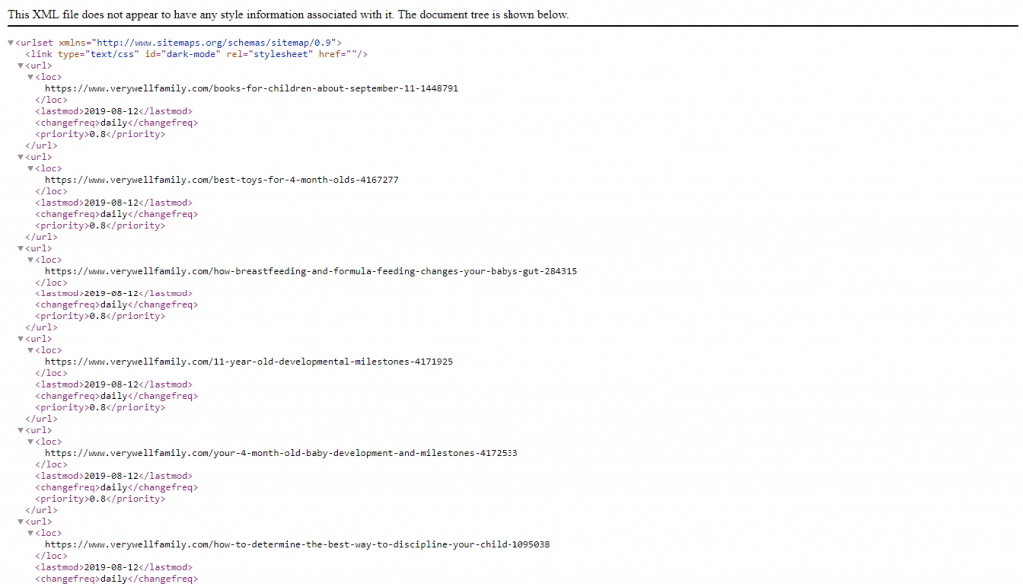

## **What Is an HTML Sitemap?**

HTML sitemaps are a visual representation of a website’s site structure. Like an XML sitemap, it lists all of the most important pages of a website but in a more human-friendly way.

HTML sitemaps make it easier to find a page when it is difficult to in a website’s main navigation menu or within internal links.

HTML sitemaps are not as common as XML sitemaps, as they aren’t well-known by casual internet users, and for websites with thousands of pages, they can be near impossible to maintain.

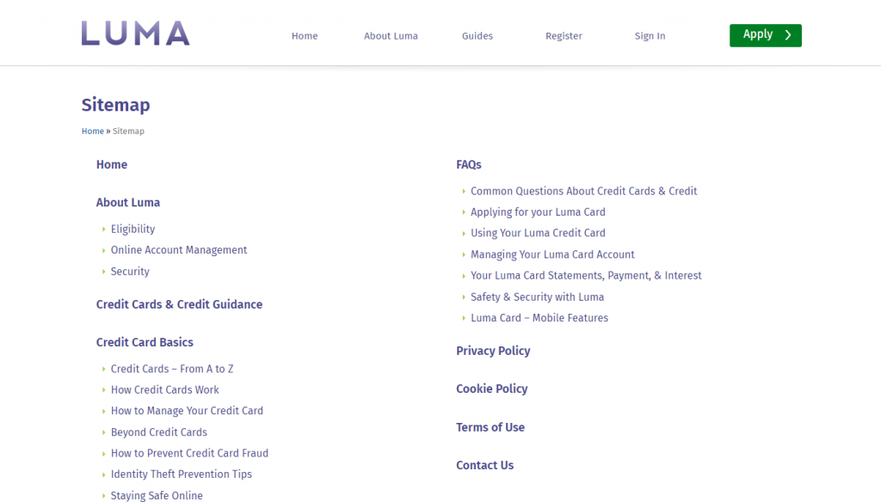

## **Do I Need a Sitemap?**

Every website should have a sitemap. Sitemaps are the perfect format for handling and maintaining URLs, especially when you’re handling tens-of-thousands of URLs, like an online eCommerce store with thousands of products.

Because you can create multiple sitemaps for a website, you can segment and manage sections of your website individually.

The most common split between sitemaps on websites is a page_sitemap.xml file and post_sitemap.xml file (due to the [number of websites built using WordPress](https://trends.builtwith.com/cms) and the Yoast plugin). This allows you to review your website’s pages and posts separately, which is useful, as the blogs of websites are typically more frequently updated than pages and they total larger numbers (10 pages versus 100 blog posts, for example).

## How to Create a Sitemap

Some websites come with sitemaps automatically built as part of their system. The biggest example of this is the WordPress [Content Management System](https://whatcms.org/What-Is-A-CMS) (CMS), which has an automatically updating sitemap file built-in.

To make the WordPress sitemap easier to handle, some people use the [Yoast SEO plugin for WordPress](https://kb.yoast.com/kb/enable-xml-sitemaps-in-the-wordpress-seo-plugin/), which segments pages, posts and so on.

Each CMS has its own sitemap management system, although some systems may need a plugin.

**Follow these instructions to create a sitemap using Screaming Frog.**

### **Step 1 – Crawl Your Website Using Screaming Frog**

Enter your website’s domain address into the toolbar and press “Start”. Depending on the size of your website, this may take some time as every page will need to be discovered and crawled.

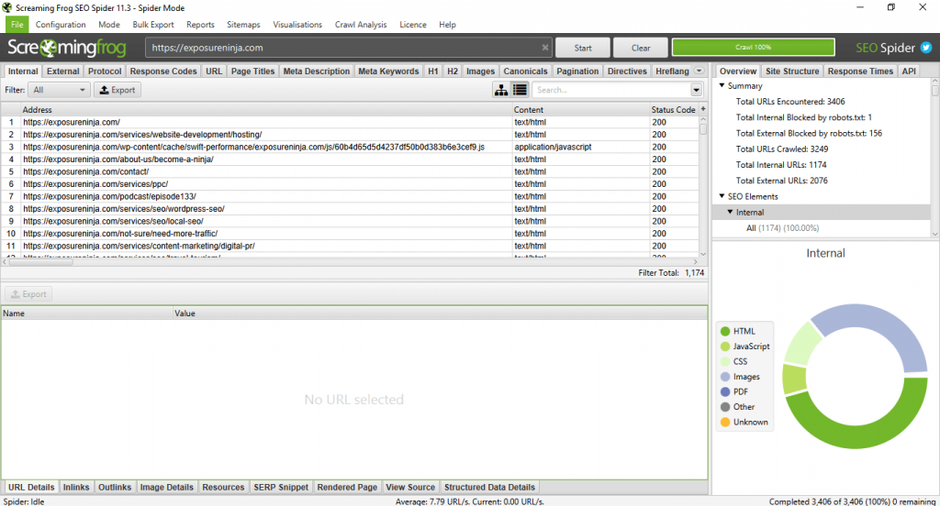

### **Step 2 – Remove Any Unwanted URLs**

Once the crawl is complete, review the complete list of URLs and look for any you do not want to include in your sitemap. If you have URLs you’d like to exclude, right-click these and select “Remove”. If you hold the Shift or Ctrl button (on Windows), you can select multiple URLs to remove at once.

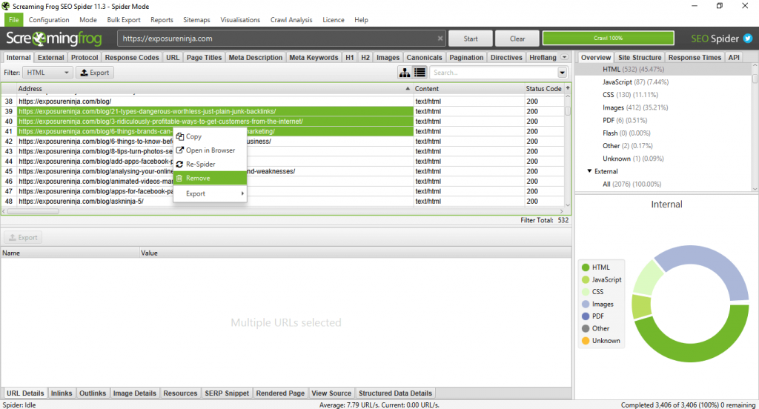

### **Step 3 – Open the Sitemap Menu**

Open the Sitemap menu on the toolbar and select “XML Sitemap”. A menu will open with several options. The default options will be to include only Status 200 URLs within the sitemap, but you can choose to include pages with noindex tags, paginated pages or those with 301 redirects.

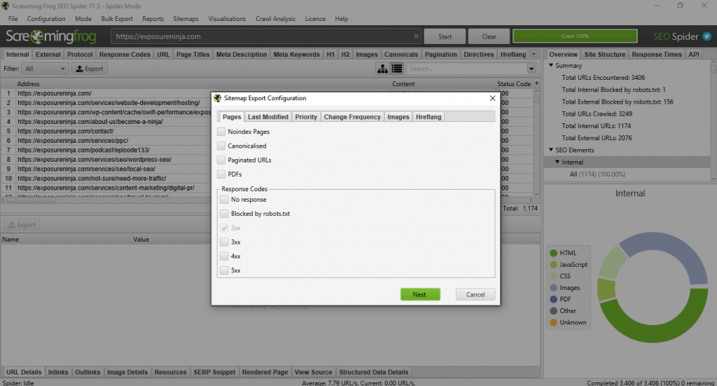

### **Step 4 – Save Your Sitemap**

Once you have finished making your edits, click the “Next” button and a Save menu will open. The default file type will be XML.

### **Step 5 – Upload Your Sitemap**

Now that you have your new sitemap, you’ll need to upload this to your website.

Unfortunately, we’re unable to advise on the best way to do this, as every website’s CMS will differ.